
A 10
SET NO : 1

Sreenidhi Institute of Science & Technology
(An Autonomous Institution)
Code No:

B. TECH. I – Year I – Semester Examinations, May, 2011 (Supplementary)
MATHEMATICS FOR BIO-TECHNOLOGY (BIO-TECHNOLOGY)

Time: 3 Hours Max. Marks : 70

Note : No additional answer sheets will be provided.

Part-A (Objective Type)
Max.Marks:20

Answer all QUESTIONS.

1. Evaluate 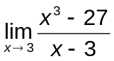.

2. Find 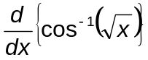.

3. Find the equation of the tangent to the curve y = 5x⁴ at (1,5).

4. If u = 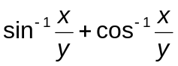, then find 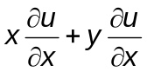.
5. Evaluate 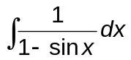.

6. Evaluate 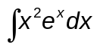.

7. Evaluate 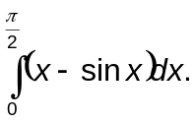
8. Solve 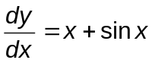.

9. Solve the differential equation by eliminating the arbitrary constant m from the equation y = mx².

10. Define function with an example.

Part – B
Max. Marks: 50

ANSWER ANY FIVE QUESTIONS.
EACH QUESTION CARRIES 10 MARKS.

1. a) Evaluate 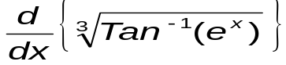. [ 5 ]
b) Evaluate 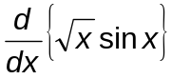. [ 5 ]

2. a) If f(x) = 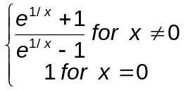Then examine the continuity of f(x) at x = 0. [5]

b) Discuss the differentiability of f(x) = | x | at x = 0. [ 5 ]

3. Find the equations of tangent and normal to the curve y⁴=ax³ at (a,a). [ 5 ]

4. a) If u = 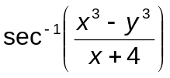, prove that 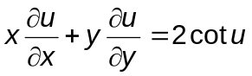. [ 6 ]

b) If z =x ^{y} + y^{x}, then find 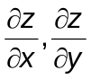. [ 4 ]

5. a) Evaluate 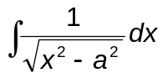. [ 5 ]
b) Evaluate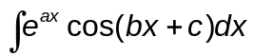. [ 5 ]

6. Find the area of the region bounded by 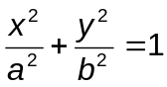.

7. a) Solve 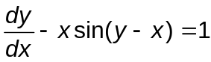. [ 5 ]

b) Solve 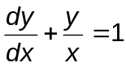. [ 5 ]

8. Solve 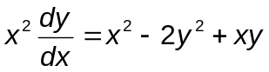.

- 0 - 0 -

